
Date……………………………….
Invitation Letter

Dear…………………………………………….

Thank you for expressing an interest in becoming a volunteer with The Scout Association. To start your application process we need to arrange to meet to enter your details onto The Scout Association database (Compass) and complete your AccessNI online application.

Your personal data will be stored on Compass to support your application process and your current and potential future involvement in Scouting. It is also kept for monitoring purposes. Some information is considered sensitive personal data under the Data Protection Act 1998 and as such will be managed as required under the Act. Further information can be found at www.scouts.org.uk/dataprotection

Could we please arrange to meet:
Date:
Time:
Venue:

- Before this meeting you need to create an AccessNI NI Direct online account to enable your AccessNI online application to be completed during our meeting. See pages 3 & 4 for step by step instructions.
If you don’t have an email address an email account could be created in your name using a free online account such as gmail or hotmail.

Please bring the following to the meeting:
- Your AccessNI NI Direct login details (email address and password).
- Three ID documents in your name; one from Group 1 and two from Group 2. If this is not possible, then four documents from Group 2 (Suitable ID documents are listed below).
- National Insurance number.
- Driving licence number (if you hold one).
- Passport number (if you hold one).
- Your address(es) for the last five years.
- Details of referees if applicable (please complete the section on page 2).
Please note - References are not required for Occasional Helpers.
List of suitable ID Documents

Group 1

- Current passport (any nationality)
- Biometric Residence Permit (UK)
- Current driving licence (UK, ROI, Isle of Man, Channel Islands or any EU country)
- Original birth certificate (UK, Isle of Man or Channel Islands) issue at time of birth
- Original long form Irish birth certificate –issued at time of registration of birth
- Adoption certificate (UK, Isle of Man or Channel Islands)

Group 2
- Birth certificate (UK, ROI, Isle of Man or Channel Islands) issued after time of birth
- Marriage/Civil Partnership Certificate (UK, Isle of Man or Channel Islands)
- HM Forces ID card (UK)
- National Insurance Card or notification letter with NI number (UK)
- Firearms licence (UK and Channel Islands)
- Bank / Building Society Account Confirmation Letter
- Electoral ID card (NI only)
- EU National ID card
- Cards carrying the PASS Accreditation logo (UK and Channel Islands)
- Senior SmartPass (Translink) (NI only)
- Current UK driving licence (old paper version)
- Examination certificates (16-18 year olds only)
- Bank/Building Society Statement (UK or EEA)
- Credit card statement (UK or EEA)
- Utility Bill (UK or ROI) – not mobile phone
- Benefit statement (UK)
- Addressed payslip
- Mortgage statement (UK or EEA)
- Financial statement (UK)
- P45/60 statement (UK and Channel Islands)
- Land and Property Services Agency rates demand (NI only)
- Work Permit/Visa (UK) (UK Residence Permit)
- Letter from a Head Teacher or Further Education College Principal (16-18 year olds in full time education – only to be used when other documentation routes are exhausted)

Page 2

References
(References are not required for Occasional Helpers)

Please add details of two people to act as referees who are known to you and who can be contacted by email. The referees should preferably have knowledge of your work or contact with young people and should be able to comment on your character and relationships with others. At least one referee should have known you for at least five years and one of the referees must not be from Scouting. Referees must not be relatives. Examples of referees include your employer, college tutor, etc.

Referee No. 1 Name:

Relationship:

Email:

Address:

Postcode:

Phone Number:

Referee No. 2 Name:

Relationship:

Email:

Address:

Postcode:

Phone Number:

Thank you.

Signed: ………………………………………………………………………………………. GSL

Page 3

To create an NI Direct AccessNI online account, open this web address:
https://accessni.nidirect.gov.uk/account/login

Click on the Green Create an account button.
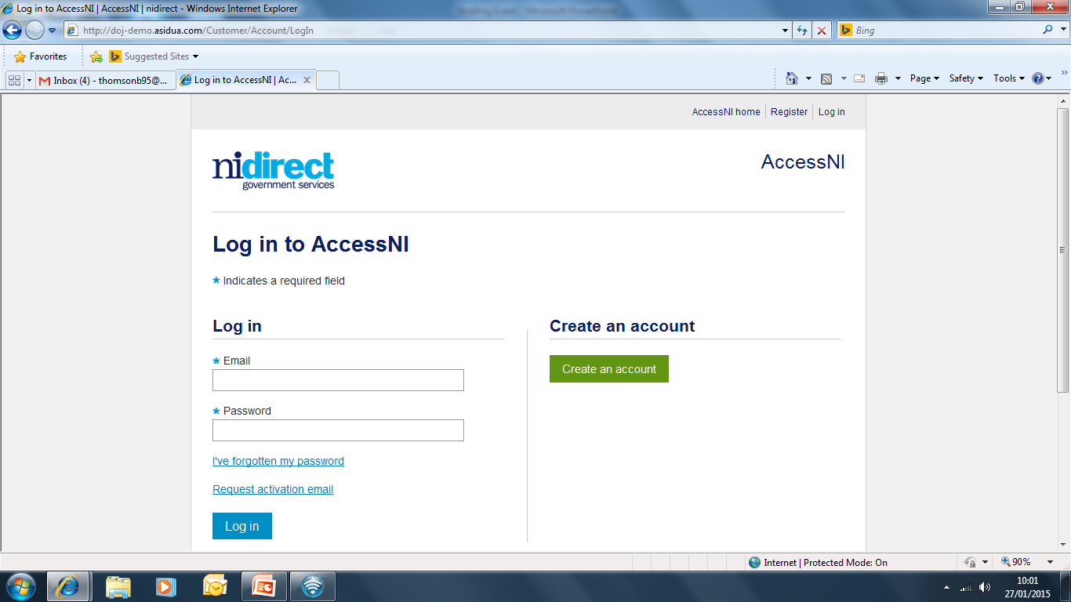

Complete the details on this form to create an account.
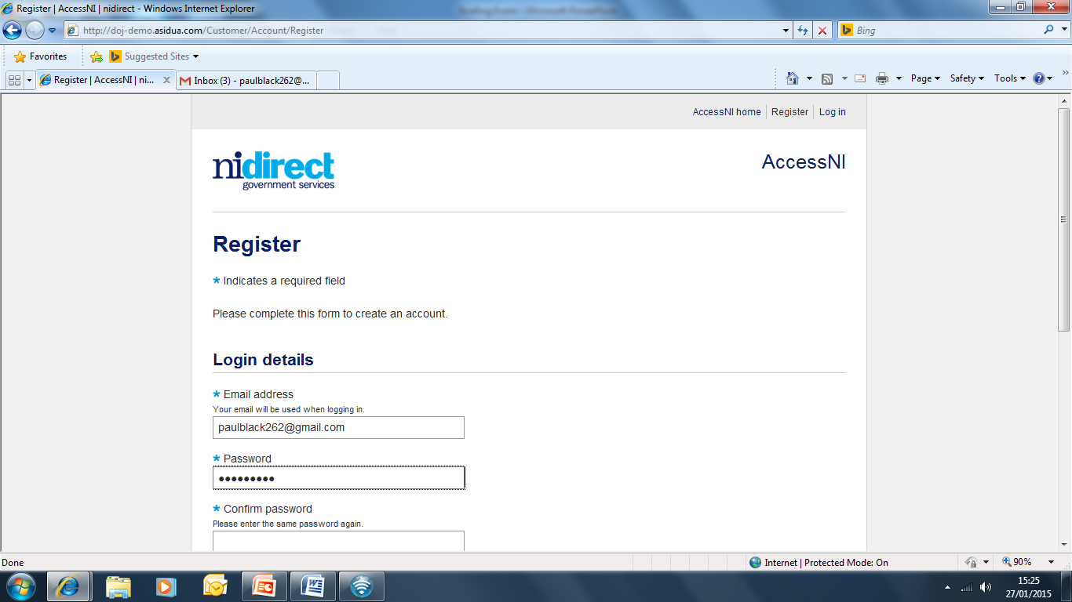

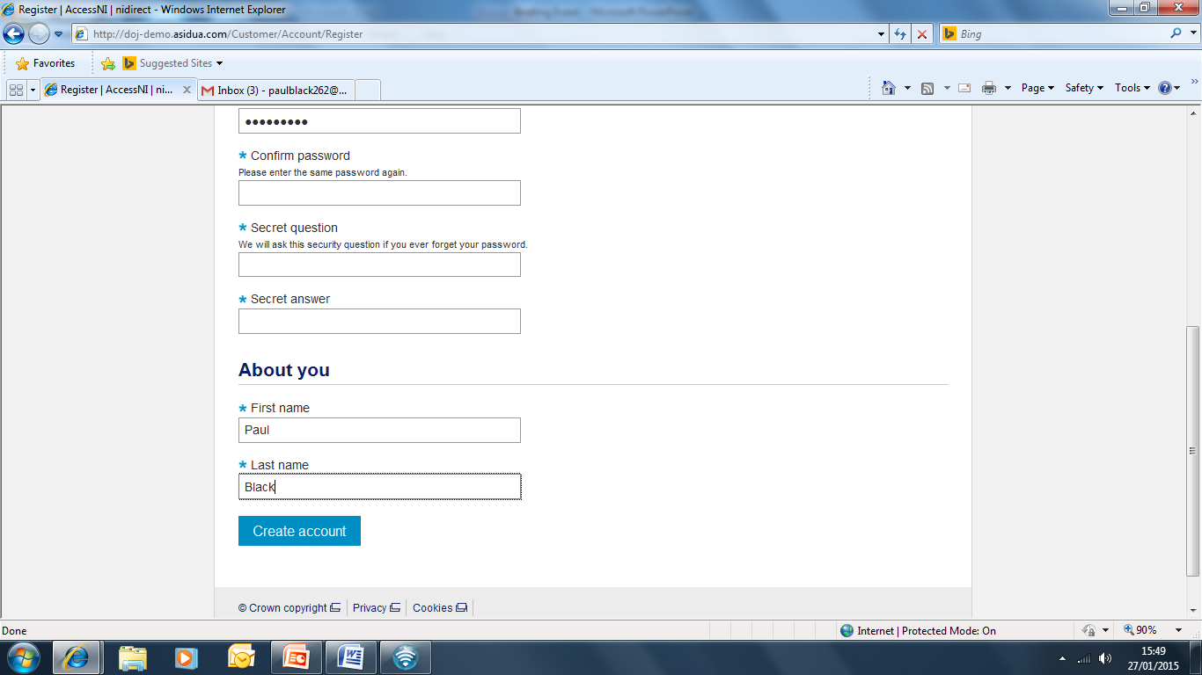

Click on Create account

Take a note of your Email address and Password as you will need this for completing your online application during
the meeting with your GSL.

Page 4

This screen will then appear
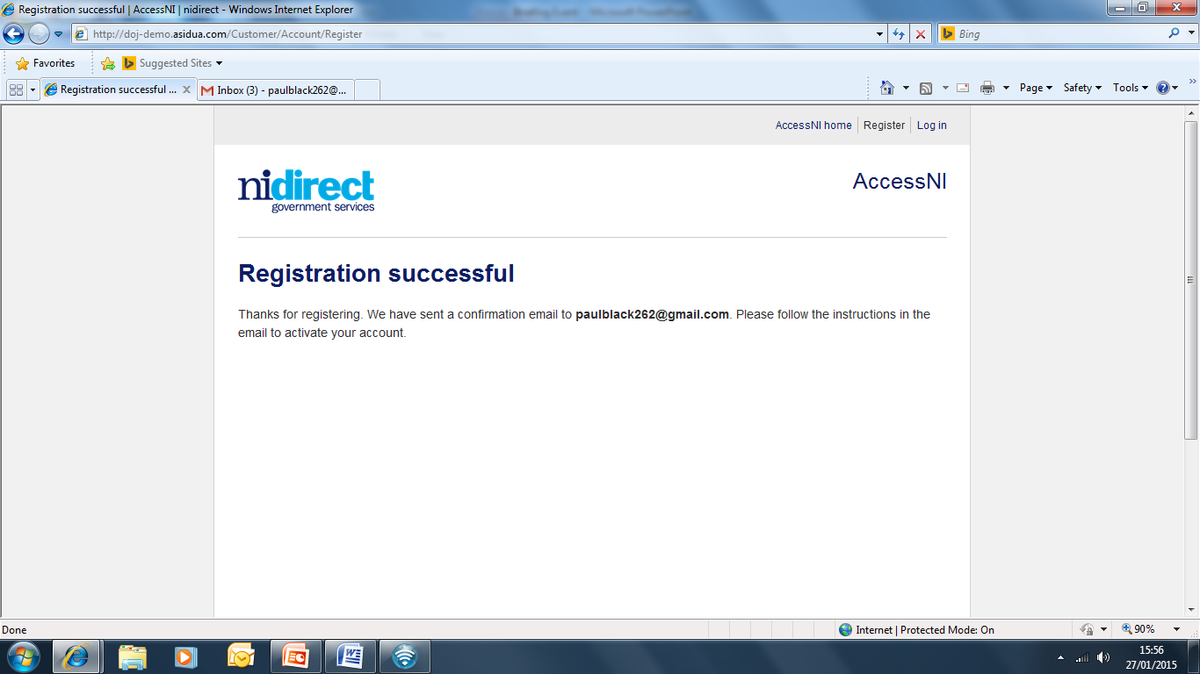

You need to log into your own email inbox where you will find a new email from AccessNI the content of which is as follows:

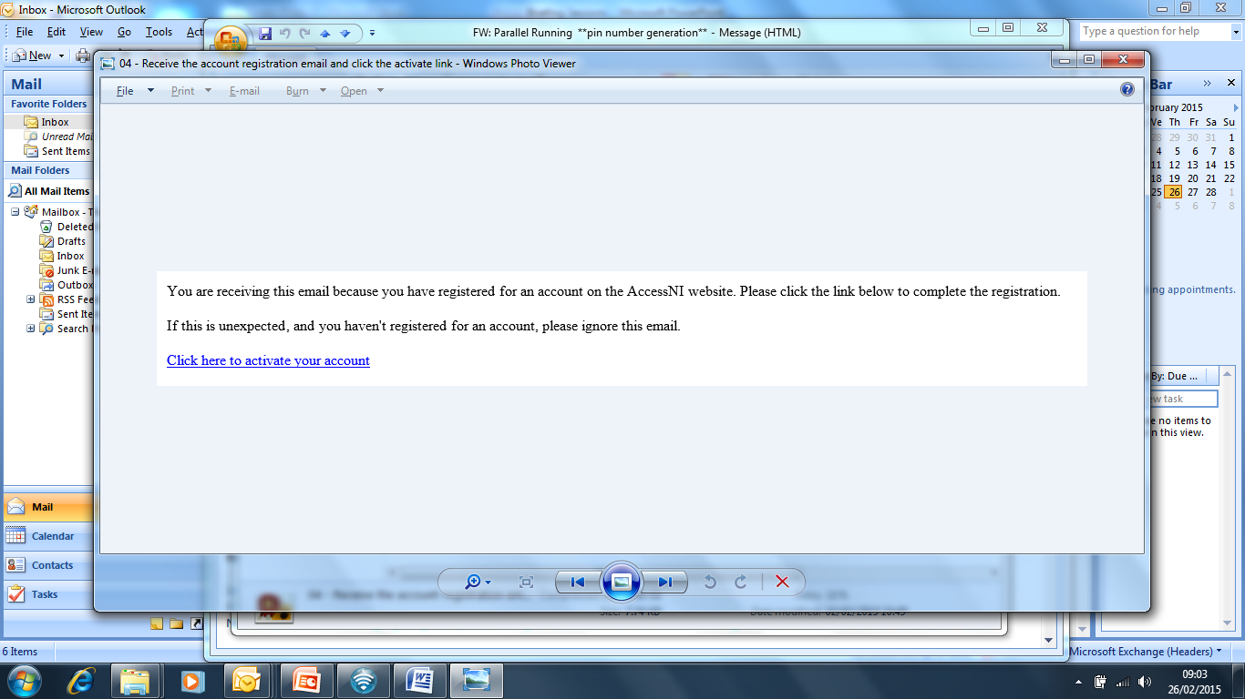

Click here to activate your account.

The remainder of your AccessNI online application will take place during the
meeting with your GSL.

